Assignment 2 (20 points)
My Healthy Eating Inc., a Toronto-based company, sells healthy food online to customers across North America. The company builds and maintains its own e-Commerce website. Over the last few years, the company has experienced rapid growth due to the increasing popularity of their products. Meanwhile, their IT operational cost has also gone up significantly.
Below is a diagram of the company’s on-premise data center environment, which is a typical three-tier application, including a load balancer, three application servers running the e-Commerce application, and a MySQL database server. In addition, the company has a total of approximately 2 TB data stored in the data center.
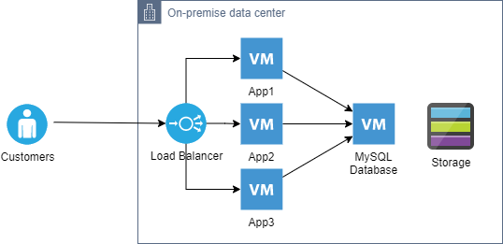
As an AWS certified cloud practitioner, you decide to write a report to the IT manager suggesting the company to migrate its on-premise data center to AWS. In the report, you need to discuss the cloud benefits, identify the AWS services to use and high-level cost estimation, and outline a brief migration plan.
Write your report below:

1. Introduction
My Healthy Eating Inc. is growing fast, and its IT costs are increasing. The company runs its website on servers in its own data center, but this setup is expensive and hard to maintain. Moving to Amazon Web Services (AWS) can help reduce costs, improve security, and make the system more flexible. This report explains the benefits of AWS, the best services to use, estimated costs, and a simple migration plan.

2. Cloud Benefits
Switching to AWS has many advantages:
• Lower Costs: No need to buy and maintain expensive hardware. AWS charges only for what is used.
• Scalability: AWS can adjust resources based on demand, so the company won’t have to overpay for unused capacity.
• Better Reliability: AWS has data centers worldwide, which helps keep the website running smoothly.
• Improved Security: AWS offers strong security tools like encryption and access controls.
• Less Maintenance Work: AWS manages servers, so the IT team can focus on improving the website instead of fixing hardware.

3. Recommended AWS Services
To replace the current system, these AWS services are recommended:
• Amazon EC2: Runs the e-Commerce website.
• Elastic Load Balancer (ELB): Distributes customer traffic evenly across servers.
• Amazon RDS (MySQL): Manages the database without needing manual updates.
• Amazon S3: Stores website files and backups safely.
• Amazon VPC: Creates a secure network.
• AWS Shield & WAF: Protects against cyber threats.
• Amazon CloudWatch: Monitors system health and performance.

4. Estimated Costs
AWS follows a pay-as-you-go pricing model. Here’s an estimated monthly cost:
• EC2 Instances (3 servers): $300 - $600
• Elastic Load Balancer: $25 - $50
• Amazon RDS (MySQL): $150 - $400
• Amazon S3 (2TB storage): $50 - $100
• Security & Monitoring: $50 - $150
• Total Estimated Cost: Around $575 - $1,300 per month (depends on usage).

5. Migration Plan
Migrating to AWS will happen in steps:

Step 1: Planning
• Check the current system and decide what needs to move.
• Choose the right AWS region for hosting.

Step 2: Testing
• Set up a small test version of the website on AWS.
• Make sure everything works as expected.

Step 3: Moving the Data
• Transfer website files to Amazon S3.
• Move the MySQL database to Amazon RDS using AWS Database Migration Service (DMS).

Step 4: Setting Up the Website
• Deploy the website on Amazon EC2.
• Connect the Elastic Load Balancer and security tools.

Step 5: Testing and Optimization
• Test the website’s speed and security.
• Adjust AWS settings to improve cost and performance.

Step 6: Going Live
• Switch customer traffic to AWS.
• Monitor the system with Amazon CloudWatch and make final adjustments.

6. Conclusion
Moving to AWS will help My Healthy Eating Inc. save money, improve security, and make the website more reliable. The migration plan ensures a smooth transition with minimal disruption.

